ICON8002 SNA

ICON 2017 Cohort

2018-12-05 13:50:05

# Social Network Analysis

This is a report generated from social network analysis of the actors within the shrimping industry on the Georgia Coast. The resulting output of the analysis demonstrates the relationships between shrimpers, dockers, and other agencies/organizations.

## Network attributes

* Diameter
* The network has a diameter of $12$. This measure is the length of the longest geodesic (the largest distance between any two vertices in a connected graph).
* Reciprocity
* The network has a reciprocity of $0.0518868$. The measure of reciprocity defines the proportion of mutual connections, in a directed graph.
* Number of edges
* The network has $848$ total edges.
* Number of egos
* The network has $229$ total egos
* Edge density
* The network has a density of $0.0162415$. This measure is the ratio of the number of edges and the number of possible edges.
* Transitivity
* The network has a transitivity of $0.1008833$. This measure is the probability that the adjacent vertices of a vertex are connected. This is sometimes also called the clustering coefficient.

## Vertex attributes

* Closeness
* The vertex with the greatest closeness is $Geissler,Franki$ (closeness of $54$). This measures how many steps is required to access every other vertex from a given vertex.
* The vertex with the least closeness is $Solomon,Mila$ (closeness of $7$). This measures how many steps is required to access every other vertex from a given vertex.
* Degree
* The vertex with the greatest degree is $Radebaugh,Angel$ (degree of $18$). This measure is the number of its adjacent edges.
* The vertex with the fewest degree is $Cheung,Kiana$ (degree of $1$). This measure is the number of its adjacent edges.

## Network plots

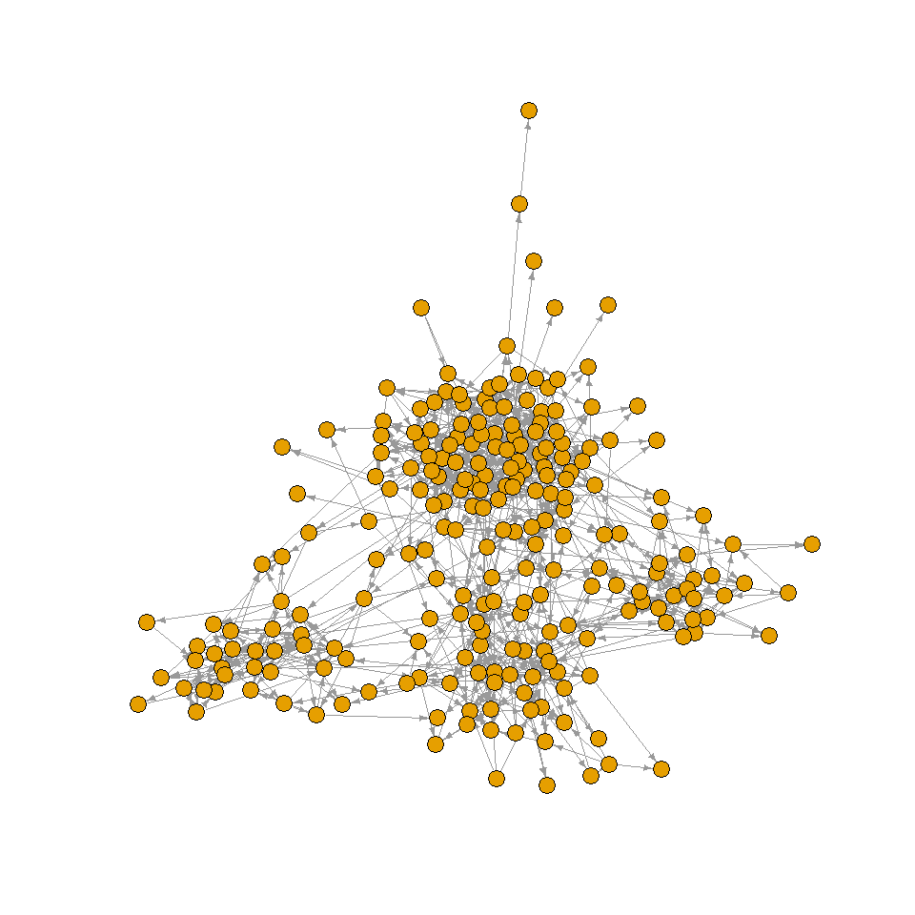

Original social network plot with no alterations (Nicely layout)

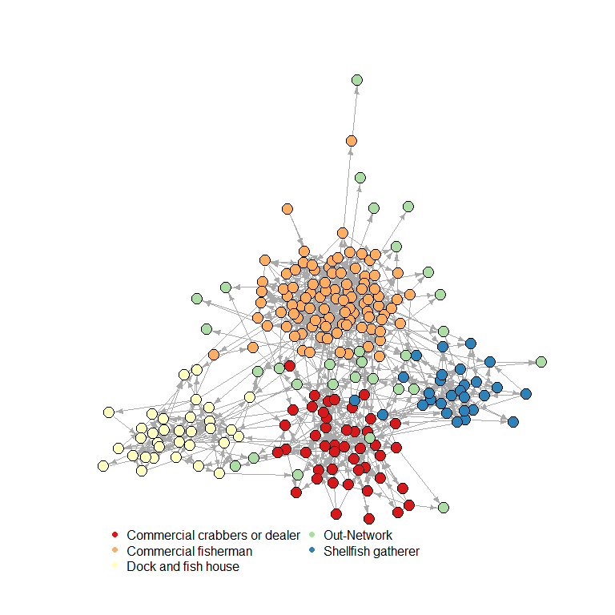

Social network plot with vertex colored based on profession (Nicely layout)

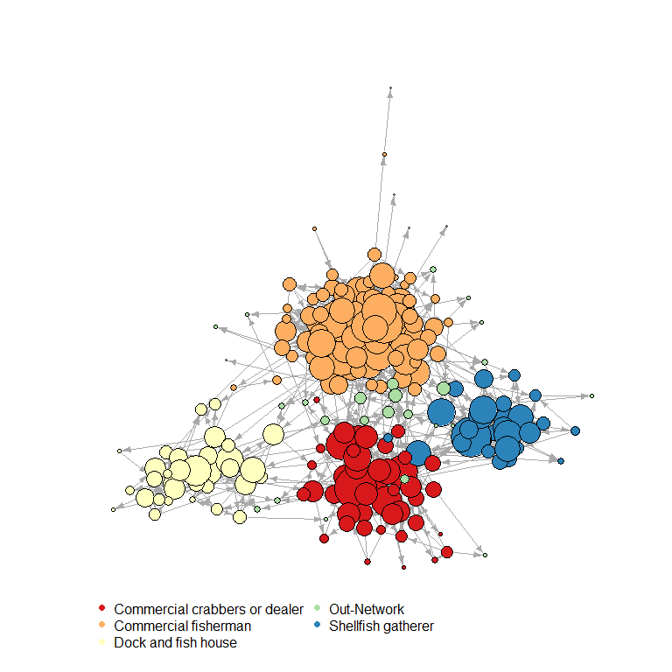

Social network plot with vertex colored based on profession and vertices weighed by total degree

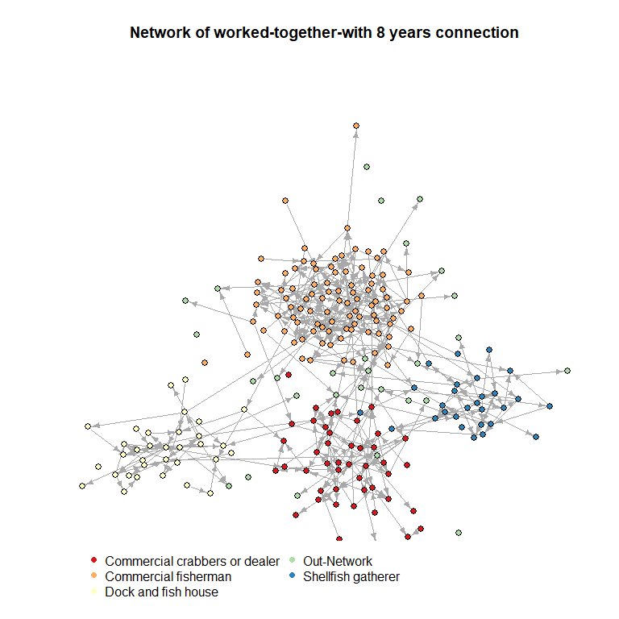

Social network plot demonstrating how long vertices have worked with each other

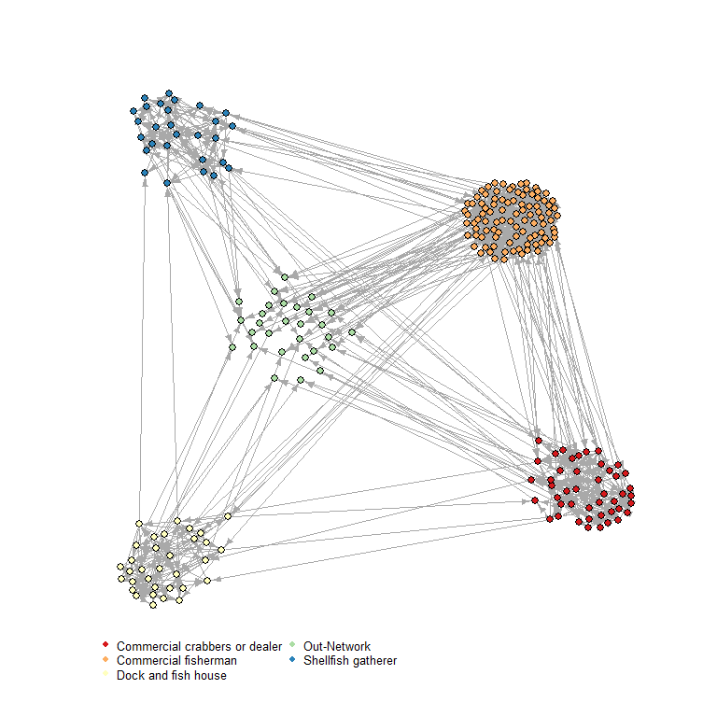 ## Keyplayers

|  |  |  |  |
| --- | --- | --- | --- |
| Statistic | A | B | C |
| Closeness | Geissler, Franki | Jones, Brandon | Gordon, Mohamed |
| Betweenness | Radebaugh, Angel | Nixon, Tessa | Fernandez, Joel |
| Degree | Leyva, Jazmin | Radebaugh, Angel | Nixon, Tessa |
| Eigenvector | Adams, Dior | Shackelford, Matthew | Radebaugh, Angel |

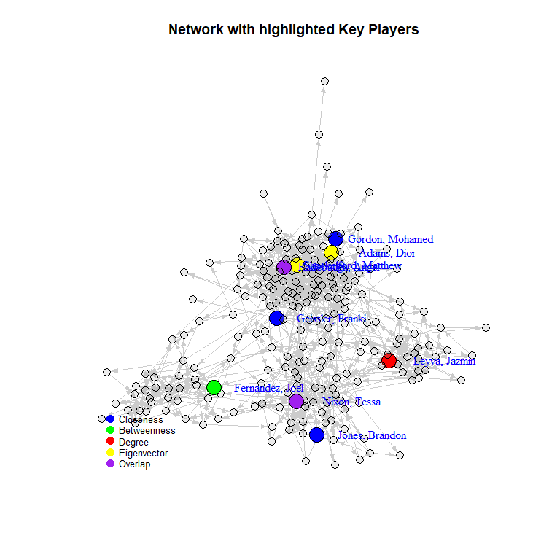

Social network plot with keyplayers highlighted based on vertex attributes